**1-Change of the form publish a mission in step  
  
STEP 3**

1-1-Step 1 : Publish a mission > Categories and subcategories

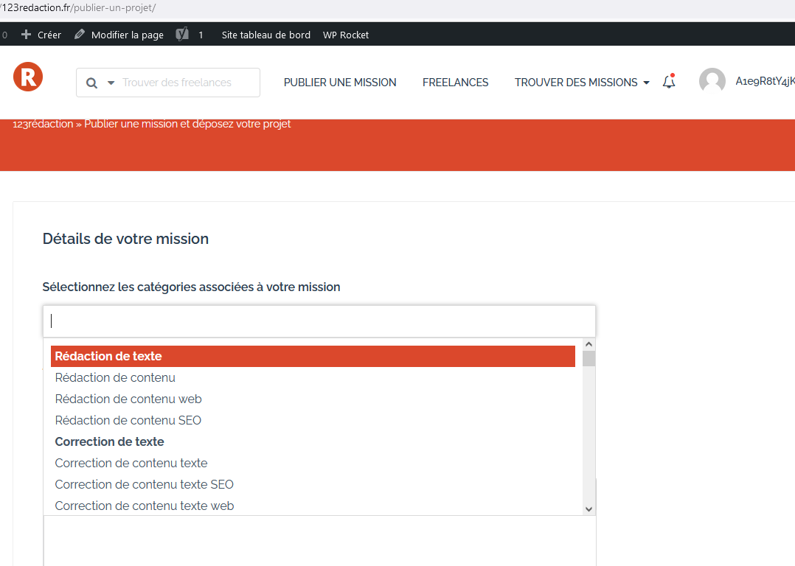

We must change this drop-down list for image blocks.

5 per line

with a block and square edge, 1px border with margins with a hover hover cursor effect to see it's selectable

You must display only the first level categories

Images or icons must be able to be added to this first level category in the back office  
  
Below the block category name text. You have to be able to put an editable sentence.

On the first page you should only have the block choice of category icons.

The icon and the text below must be displayed in the block  
  
ps : At the top of these blocks you have to think about putting editable text

1-2- Step 2 :  
  
Display in individual list of subcategories by category

Center on the page the drop-down lists of the select multiple subcategories linked to the parent categories, one below the other

At the bottom of the drop-down lists put a "Ignore" button, this button takes you to the next step.

And a Save button, which saves the choices and takes you to the next step.

It is necessary to display only the drop-down lists of the subcategories in connection with the categories previously selected.

Ps : The selection of subcategories is not mandatory

1-3- Step 3  
  
The same form as currently is kept.  
  
You have to move the drop-down list field (Skills) first

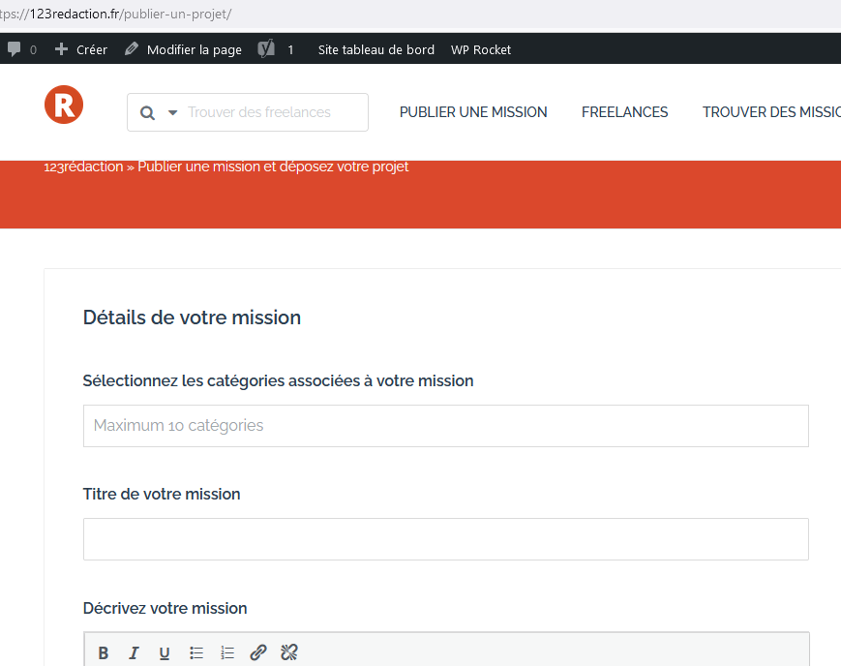

For the skills field, you must display the order of the options in the drop-down list in ascending order according to the slug.